
Lab - Install Windows
Objectives
In this lab, you will install Windows 10.

Background / Scenario
In order to complete many of the remaining labs in this course, you will need to use Windows. This lab provides a basic installation in order to get Windows up and running on the lab PC.

Required Resources
- A computer with a blank hard disk drive
- Windows 10

Instructions Step 1: Starting the Installation Media
- Insert the Windows 10 installation DVD into the DVD-ROM drive or plug the USB flash drive into a USB port.
- When the computer starts up, watch for the message Press any key to boot from CD or DVD.
If the message appears, press any key on the keyboard to boot the computer from the DVD. If the press any key message does not appear, the computer automatically starts loading files from the DVD.
The computer starts loading files from the DVD or USB flash drive.

Step 2: Configuring Initial settings
- The Windows Setup window opens. Click Next to continue unless you need to change the default settings.
- Click Install now to continue the installation.

Step 3: Collecting Information
- In the Enter the product key to activate Windows window, enter the product key.
Note: You can find the product key on the case or sleeve in which the Windows DVD was packaged, or you can get it from your instructor.

- In the License terms window, read and confirm that you accept the license by selecting the box I accept the license terms. Click Next.
- In the Which type of installation do you want? Window, click Custom: Install Windows only (advanced).
- In the Where do you want to install Windows? Window, select the hard drive or partition on which Windows will be installed. In this example, click to select Disk 0 Unallocated Space. Click Next to continue. Setup has finished collecting information for the installation.
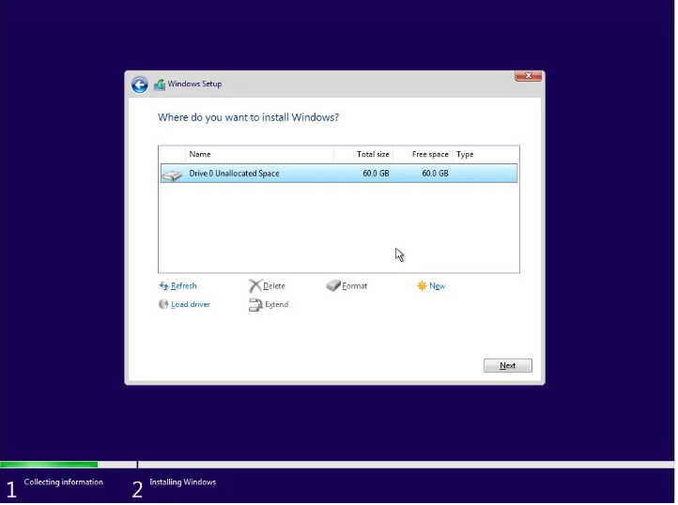
Lab - Install Windows

Step 4: Installing Windows
- The Installing Windows window opens. Windows will take some time to copy the files and install the OS on your computer. During the setup, the computer will restart several times.
- When the Windows needs to restart to continue window opens, your computer will automatically restart or you can click Restart now.
- If you get the message Press any key to boot from CD or DVD…, do not press any key and Windows will boot from the hard disk to continue the installation.

Step 5: Basics Setup
In this step, you will select your region and your keyboard layer.
Note: The personalization sub steps maybe different depending on your Windows version. a. Verify the region and select yes. If not, choose your region and select yes.
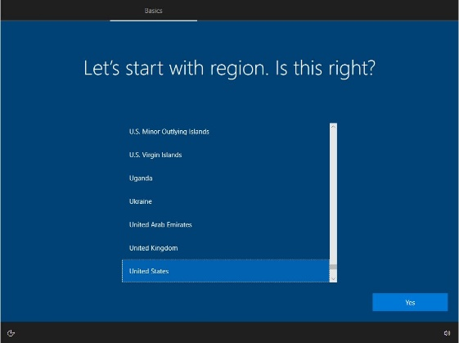
- Verify the keyboard layout and select yes. If not, choose your keyboard layout and select yes.
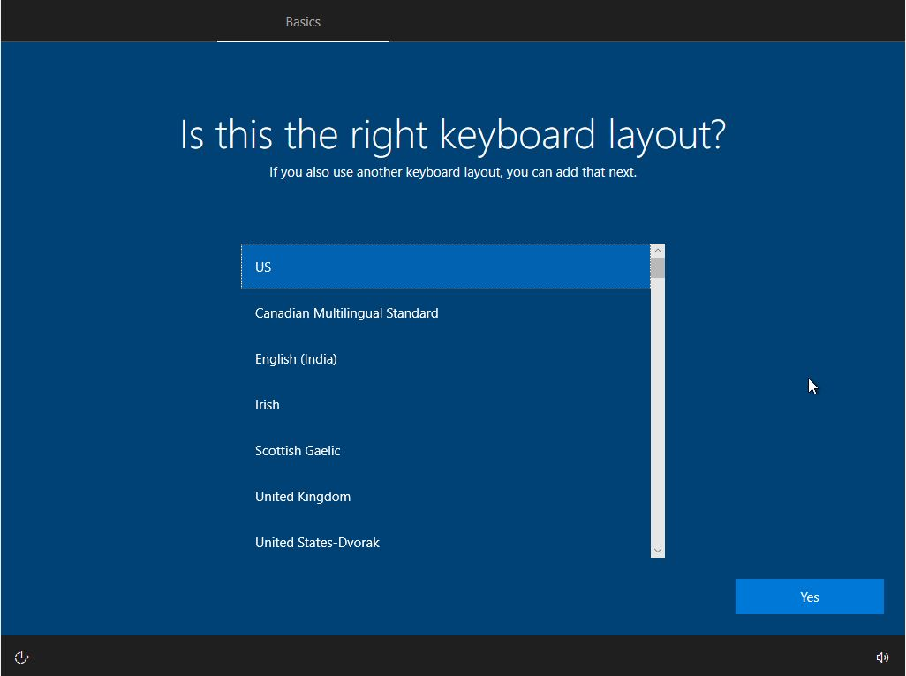
- Click Skip if you are not adding a second keyboard layout. Otherwise, click Add layout and answer the prompts to add a second layout.
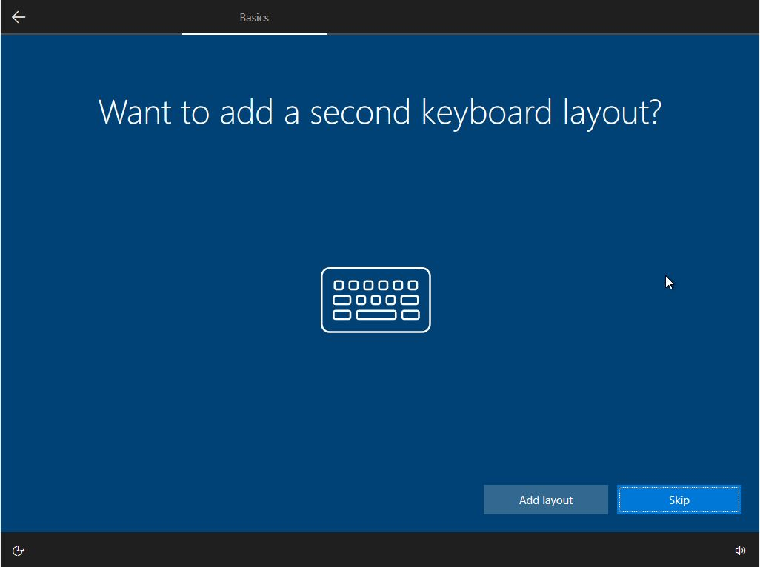

Step 6: Network Setup
In this step, the installation may continue without your input. If prompted, provide the installation with the necessary information.
Select Set up for personal use. Click Next to continue. Your instructor may ask you to choose to select Set up for an organization.

Step 7: Account Setup
In this step, you will set up a local account to access the computer. You will not be creating a Microsoft account for this exercise. If you already have an account or choose to do so, you may use your Microsoft account for this step.
Note: The account setup sub steps maybe different depending on your Windows version.
- Click Offline account to create a local account. If you already have a Microsoft account and choose to use it, enter the required information and click Next to continue.
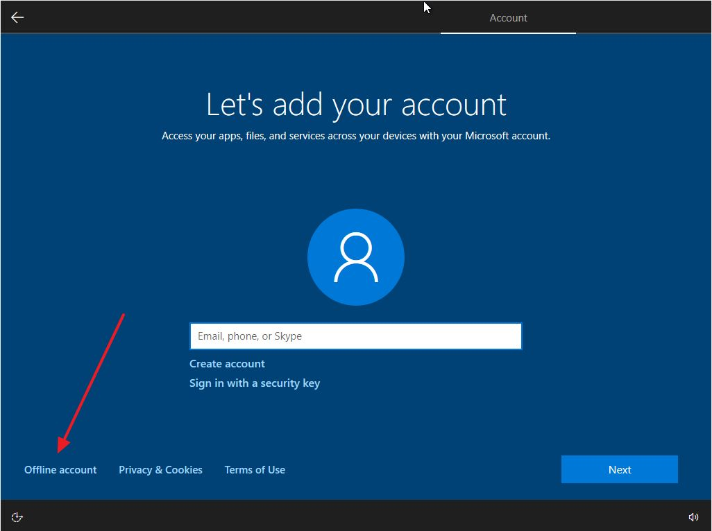
- Click No to continue using a local account, instead of Microsoft account.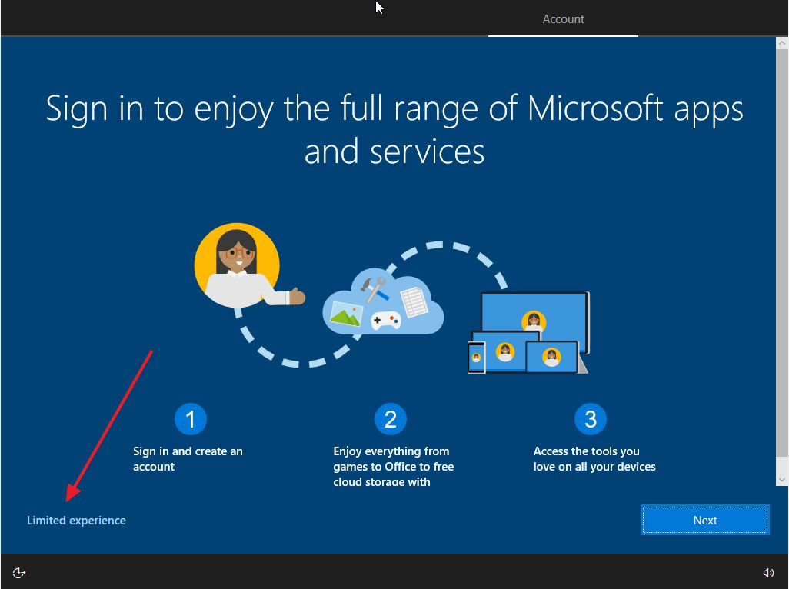
- Enter a username and click Next to continue.
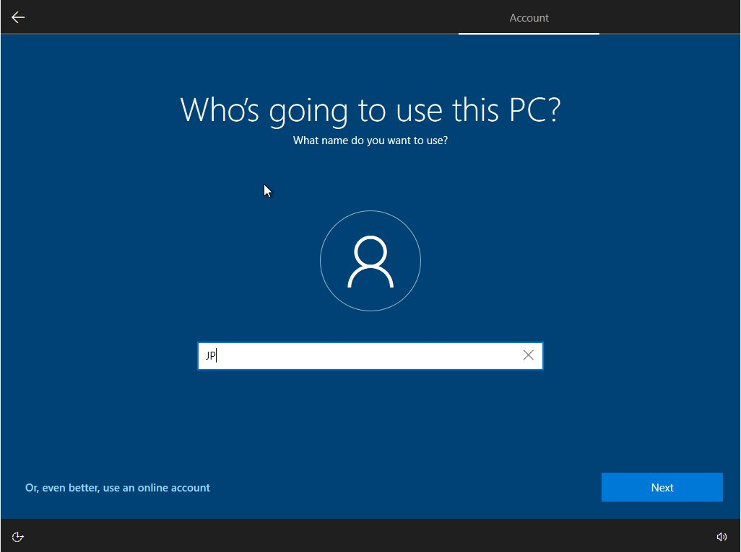
- Create a password and confirm the password when prompted. Click Next to continue.
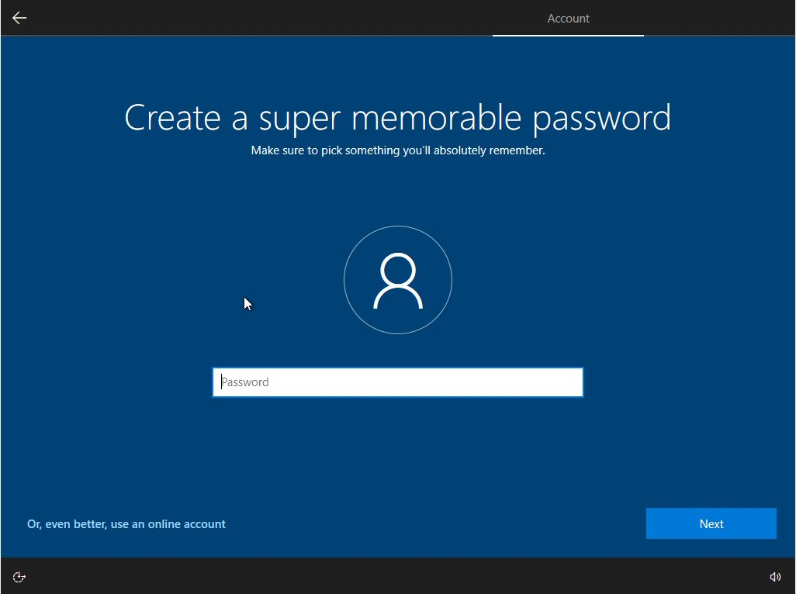
- Answer all the security questions and click Next to continue. 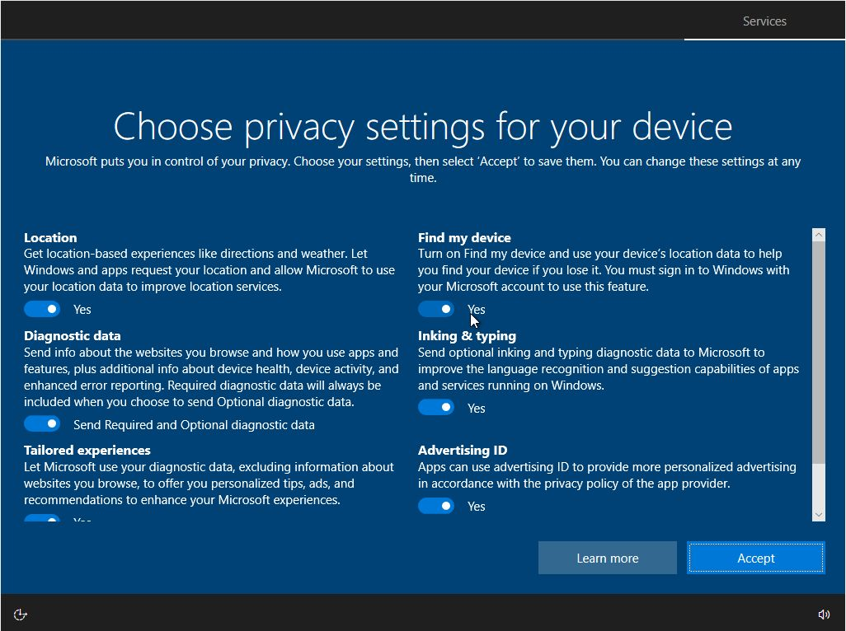

Step 8: Services Setup
In this step, you can give permission to use Cortana and select your privacy settings.
- You can choose to use Cortana as your personal assistant. Click Yes or No to continue.
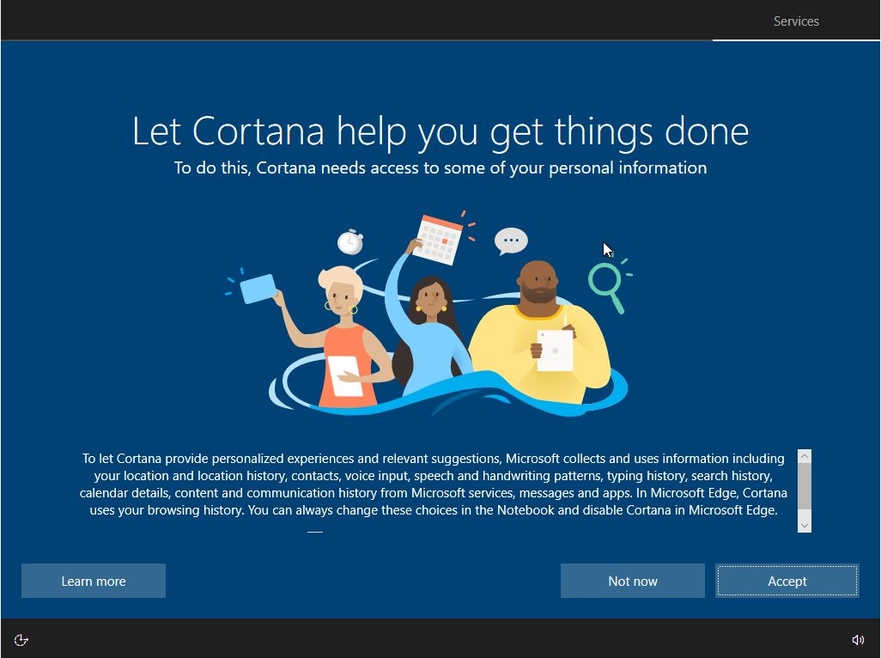
- Read the privacy settings and click Learn More to find out more details. Then decide which features to use and click Accept to continue.
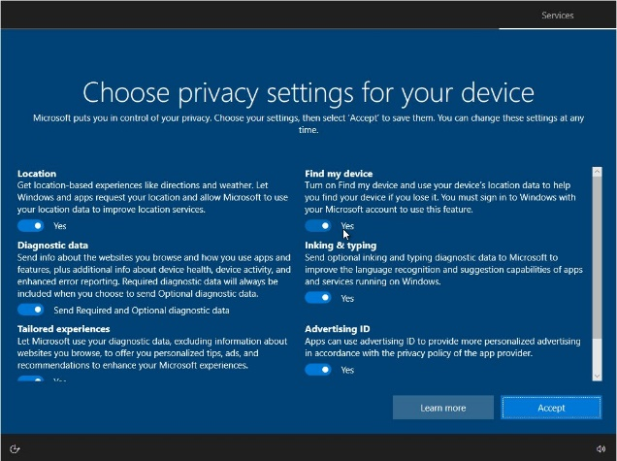

Step 9: Finishing the Installation
- When you are finished with the installation, Windows continues to finalize your settings.
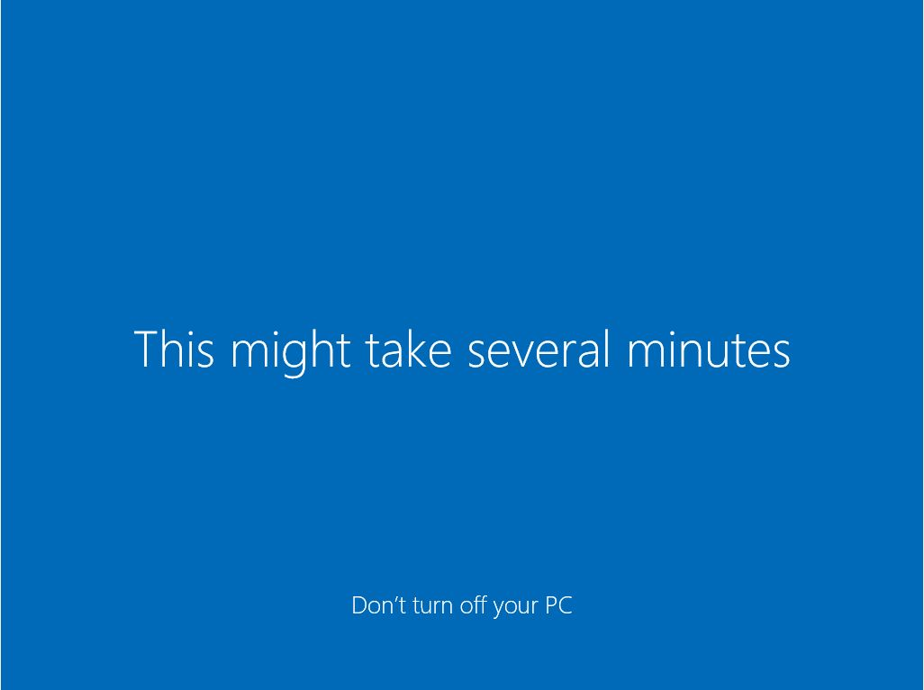
Lab - Install Windows

- After the installation is completed, the Desktop displays and you are logged into Windows for the first time.
End of Document 

